Data Structures (2028C) **Homework 1** - **Floor Layout Designer**

Topics covered***: OOA/D/P Working with Classes***

*Homework due:* ***October 9, 2020***

**Objective:**

The objective of this homework is to create classes for specifying a 2D space layout.

**Scenario:**

Given a set of resources and constraints to build a home, you are creating a floor layout planner (FLP) to help you design a home that fits your needs.

A space can be partitioned into smaller areas, each serving a purpose and can be labeled as such. For instance, a piece of land, called lot, can contain a house, which can contain a series of partitions called rooms. Using this tool you may specify the layout of the rooms of a residence, called a floor plan, consisting of basic room types and spaces for various activities, such as lobby, hallway, bedroom, bathroom, utility room, living room, kitchen, etc.

Space can be specified by its geometry, that is, a set of points and line segments made up by pairs of points. We can connect a sequence of segments forming polyline. And when we let the starting point be repeated to be also the end point, the polyline will form a loop thus creating an area, a polygon. For the sake of simplicity, we will start by only considering a basic polygon, a rectangle. Only four points are needed to specify a rectangle. With this notion of geometry, we can now think in terms of partitioning a 2D space into non-overlapping rectangles representing rooms or spaces.

Furthermore, we need additional information to make wise decision about the functionalities of the rooms in the layout. We will use the notion of topology, which can provide us useful concepts of connectedness, adjacency, and some global information. The four sides of each rectangle are equivalent to the four bounding walls of the room that the rectangle represents.



The boundary can serve as interface to the adjacent areas and may contain openings such as doors or windows, and even be open space. Each wall will have two sides, each corresponds to a part of the adjacent partition boundary. The side of the walls can be labeled either as interior or exterior, depending whether it is facing outside or inside of the house. An opening on an exterior wall can be an instance of the main entrance door, or a side door, that interfaces to the inside space of the house, say the lobby space or kitchen. Windows are also openings to the outside, but only partially. Bedrooms are private spaces and, therefore, they normally are located far from the entrance door. Living space is a more public space, thus, normally, it should be connected to multiple rooms for easy access, and bathrooms should be easily accessed from both bedrooms and general areas. See an example of a typical floor plan drawing. – how to build

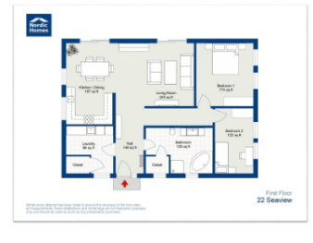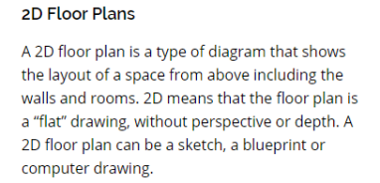

Part A – OOD - Design the classes needed for your FLP application. Consider generalization and specialization, association, and aggregation. The classes should contain important attributes, such as geometry (size, dimensions, and placement), topology (connectedness, adjacency), and function (the room type).

Part B – OOP – Design the code to create a suitable data structure for storing floor plan information.

Make all necessary assumptions to design a layout of a home, e.g., as the one shown above with two bedrooms, bathroom, kitchen, and other utility spaces. Make sure to explain all the functions required to create space/rooms with desired dimensions, and to place them in a layout representing the floor space. Write a driver program to generate the description of the layout of the rooms, given in terms of a data structure, and output some key design information, such as total square footage (the size of the home space), the private space and the public space.

**Submission:**

Submit a report of both Part A and B.

Part A report should include the problem statement, the requirements, the assumptions made, and the rationale behind why and how your classes are designed and derived.

Part B should include the coding, sample results printouts, and instructions for compiling and running the programs, the source code files and any required data files.

This homework can be done in group. Make sure to include the name of all group members (up to four members), and what each member contributed.

**Grading:**

1. 40% - Part A – OOD.
2. 40% - Part B – OOP.
3. 20% - Documentation.



Bedroom: BR

Lobby: LB

Hallway: HW

Bathroom: BT

Living Room: LV

Kitchen: KT

Eating Area: EA (Dining room & breakfast area)

Laundry: LD

Wall: W

Door: DR

Open Space: OS

Window: WW

Lot: LT

Home: HM

Furniture

Appliance

Rectangle: {P1, P2, P3, P4}

Point: P(x, y)

Recommended size and dimensions (based on the function)